Schmidt, Wayne (based mainly on Roger Underwood (2006) “Old Growth Foresters. The lives and times of West Australian Foresters”)
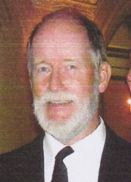
Wayne had a forestry degree from Purdue University in Indiana and Masters degree from University of California at Berkeley. He worked for the U.S. Forest Service for several years. In the early1970s he worked for Peter Kimber at Dwellingup Research. In the late 1970s he worked in the recreation area and in 1980s went back to USA for 3 years to do a post graduate degree in landscape architecture at the University of Michigan. He worked for CALM in forest recreation and landscape management at Kensington in mid 1980s. Manager Recreation & Landscape Branch late 1980s-early 1990s.
Retired 2008. There is now a Wayne Schmidt Award, which honours Wayne’s career. It involves a monetary reward towards the cost of a career achievement plus a 12 month placement of a painting. Awarded Public Service Medal on Australia Day 2009, in recognition of the leadership, innovation and vision he brought to the department in a 27 year career.

